bdtronic uses decentralised drive solutions by AMKmotion for dosing machines:

**Out of the control cabinet**

**Due to the tight supply situation, bdtronic was looking for new positioning drives for its dosing machines. The machine builders found what they were looking for at AMKmotion: the new, decentralised and compact drive solution made by the specialists in Kirchheim unter Teck works very precisely, saves space in the control cabinet, simplifies installation – and offers reliable availability.**

bdtronic is a global mechanical engineering company for 1C and 2C dosing technology, plasma pre-treatment, hot caulking and impregnation technology for electric drives. In addition to its headquarters in Weikersheim, in the north-east of Baden-Württemberg, the provider of comprehensive process solutions operates two further production sites in Italy and the USA, along with seven service and sales subsidiaries in Europe, Asia and North America.

bdtronic employs a total of more than 480 people around the globe. Its systems are supplied to customers in the automotive industry and the electrical and electronics sector, as well as in medical technology and the pharmaceutical industry. bdtronic’s technologies are particularly important in the production of electric and hybrid motors, batteries and the power electronics in modern vehicles: in addition to tier 1 and tier 2 companies, bdtronic also supplies numerous OEM customers worldwide.

bdtronic was looking for a new compact drive solution for its dosing machines. At the end of 2021, there were long delays in component deliveries and the supply was no longer secure. “We consistently focus on optimisation, both in our systems and in our processes,” says Andreas Olkus, Head of the Dosing and Plasma Business Unit at bdtronic. As a result, the company decided to look for another partner able to offer new solutions for the drives, so it contacted AMKmotion. “We’ve known AMKmotion and its products for a very long time and have worked together successfully on various occasions, too. That’s why we went knocking on the door in Kirchheim,” says Olkus.

**Impressive concept with short delivery times**

“To be specific, it was a matter of equipping dosing machines with precise positioning drives for the horizontal and vertical axes, keeping the space requirement in the control cabinet as low as possible and supplying bdtronic with all components reliably and promptly,” says Konrad Beier, sales engineer with AMKmotion. He was responsible for the bdtronic project. “We had a think about it and, in addition to conventional planning, i.e. with the drive electronics in the control cabinet, we also suggested another elegant option to bdtronic – a decentralised solution in which the drive technology is located along with all the control units directly in the machine and is connected as on a daisy-chain basis.”

The package consists of the decentralised servo converter iC5, which combines feed and servo inverter on the surface of half an A4 sheet. The feed supplies a continuous output of five kilowatts and ten kilowatts at peak to generate the direct current (DC) bus. In addition, there are three or four iX5 decentralised servo inverters with IP65 protection for connection to the DC bus and real-time Ethernet communication. Depending on the system design, four or five convection-cooled synchronous servo motors of the DT4-1 and DT4-2 series move the X, Y1, Y2 and Z axes. The motors with single-turn encoders offer high torque and power density as well as very high dynamics, with acceleration of up to 100,000 rad/s². “Our decentralised variant offers the user numerous advantages,” Beier explains, and he lists them: “Drive components in the control cabinet are no longer required, the cabling is very straight forward thanks to the daisy chain, installation is much faster, the energy exchange via the DC bus increases the energy efficiency of the entire system, the solution runs reliably and it is durable. On top of that, since we use standard components, there are no additional costs for application-specific adaptations and we are able to deliver at short notice.” Another big plus: with the combination proposed by AMKmotion, safety functions such as Safe Limited Speed (SLS) are now also possible simply as FSoE (Fail-Safe over EtherCAT).

**Collaborative partnership**

The decentralised concept impressed Andreas Olkus’ team and the project quickly got off the ground. “The proposal met our specifications exactly, and the quick availability was excellent,” says Andreas Kubera, who works in electrical design at bdtronic. “This allowed us to plan more compactly, the cabling was simpler so it required less effort, and we didn’t need additional air conditioning units in the control cabinet.” After the first tests on the prototype in November 2021, the technicians paid a visit and a test run was carried out at bdtronic’s premises. “We were surprised how quickly and easily we were able to integrate the component into the existing designs,” says Kubera. And so it was that in November AMKmotion already received an order for the first 250 drives – which the company was able to deliver on schedule, too. A second large order followed as early as May 2022.

Kubera was pleasantly surprised by the short implementation time: “It usually takes six months for a drive train like this to run stably. With AMKmotion we managed to get the whole thing up and running in just four weeks.” In addition to the elegant technical solution, other key factors on this project included close and cooperative collaboration and the open communication. “It really was a lot of fun and we can rely on the solution,” says Andreas Olkus in summary. “We’ve now fitted quite a number of systems with the new solution and we’re getting nothing but positive feedback.”

*6.011 Zeichen inkl. Leerzeichen*

***Meta-Title:*** *bdtronic uses decentralised drive solutions by AMKmotion to fit in its dosing machines.*

***Meta-Description:*** *Thanks to the new, decentralised and compact drive solution by AMKmotion, bdtronic saves space in the control cabinet of its dosing machines while at the same time benefiting from lower installation costs and high availability.*

***Challenge:*** *Due to the tight supply situation, bdtronic was looking for space-saving positioning drives for its dosing machines. AMKmotion had just what they were looking for.*

***Solution:*** *The new, decentralised and compact drive solution made by the specialists in Kirchheim unter Teck works very precisely, saves space in the control cabinet, simplifies installation – and offers reliable availability.*

***Keywords:*** *AMKmotion, bdtronic; dosing machines; decentralised drive solution; servo converter; iC5; servo inverter; iX5; convection-cooled synchronous servo motor; DT4-1; DT4-2*

***Social media (for AMK channels):*** *Due to the tight supply situation, bdtronic was looking for new positioning drives for its dosing machines in autumn 2021. The mechanical engineers found that we were able to offer what they were looking for: we delivered a decentralised and compact drive solution that works very precisely, saves space in the control cabinet, reduces installation effort and cos*ts, *and offers reliable availability.*

***Social media (for editorial staff):*** *Due to the tight supply situation, bdtronic was looking for new positioning drives for its dosing machines in autumn 2021. The machine builders found what they were looking for at AMKmotion: the specialists in Kirchheim unter Teck delivered a decentralised and compact drive solution that works very precisely, saves space in the control cabinet, reduces installation effort and costs, and offers reliable availability.*

**Captions**

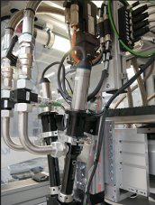

**Image 1:** AMKmotion supplied the precise positioning drives for the horizontal and vertical axes of bdtronic’s well-established dosing machines.

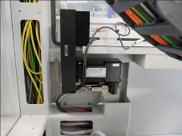

**Image 2:** Depending on the system design, four or five convection-cooled synchronous servo motors of the DT4-1 and DT4-2 series move the X, Y1, Y2 and Z axes.

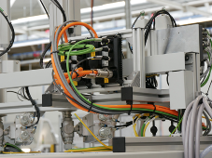

**Image 3:** Space in the control cabinet is provided by a decentralised solution in which the drive technology is located along with all control units directly in the machine – for example, the iX 5 servo inverter that controls the motor.

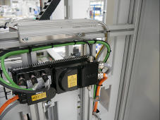

**Image 4:** The drive components are connected on a daisy-chain basis. This significantly reduces cabling. The compact iC 5 decentralised servo converter combines the power supply and servo inverter on the surface of half a sheet of A4 paper.

Ein Bild, das Im Haus, Gerät, Fräsmaschine, Armaturenbrett enthält.

**Image 5:** View into the machine.

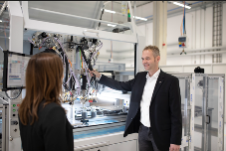

**Image 6:** “It really was a lot of fun and we can rely on the solution,” says Andreas Olkus in summary. “We’ve now fitted quite a number of systems with the new solution and we’re getting nothing but positive feedback.”

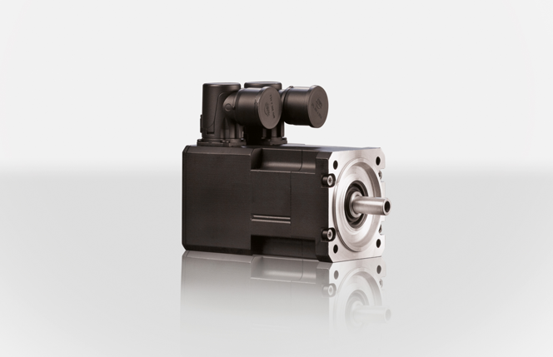

**Image 7:** The convection-cooled synchronous servo motor of the DT4 series by AMKmotion.

Ein Bild, das Kamera, Elektronik enthält.

**Image 8:** The iC5 decentralised servo converter combines power supply and servo inverter. The feed supplies a continuous output of five kilowatts and ten kilowatts at peak to generate the direct current (DC) bus.

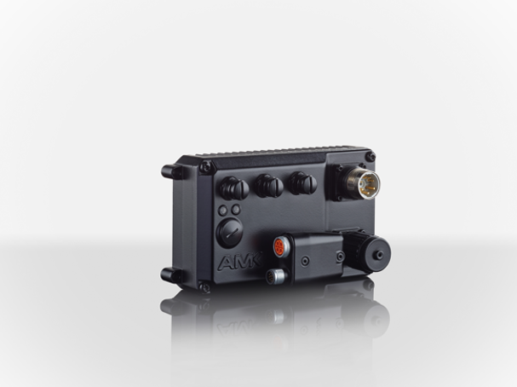

**Image 9:** AMKmotion’s servo inverter iX5 with IP65 protection for connection to the DC bus and real-time Ethernet communication.

Ein Bild, das Im Haus, Boden enthält.

**Image 10:** The bdtronic process solutions range from individual cells to fully automated systems for dosing, plasma pretreatment, hot riveting or impregnation.

Ein Bild, das Zubehör, Behälter enthält.

**Image 11:** The bdtronic systems apply heat-conducting materials and electrical insulation materials – for example in inverters for electric cars.

**Image credits:**

**Image 1 – 5:** bdtronic

**Image 6**: Samuel Becker

**Image 7 – 9:** AMKmotion GmbH + Co. KG

**Image 10 + 11:** bdtronic

**About AMKmotion**

AMKmotion specialises in the development and manufacture of electric drive systems and sees itself as a long-term partner in the field of industrial mechanical engineering and plant engineering. The company’s aim is to help its customers achieve technological leadership by integrating individual and sustainable solutions.

The basis for this is AMKmotion’s hands-on mentality, combined with expertise acquired in more than 60 years of company history. We attach particular importance to personal advice and trusting cooperation with customers.

The company was founded in 1963 as AMK Arnold Müller GmbH & Co. KG. It has belonged to the Arburg family since 2021 and has operated under the name AMKmotion GmbH + Co KG since then. The portfolio includes electric drive technology, control technology and industrial automation technology. AMKmotion has a total workforce of 500 people. In addition to its headquarters in Kirchheim unter Teck, AMKmotion has production sites in Weida (Thuringia) and in Gabrovo, Bulgaria, as well as twelve branch offices around the world.

**Contact**

AMKmotion GmbH + Co KG

Anja Schaber

Marketing Manager

Gaußstraße 37-39

73230 Kirchheim unter Teck

Germany

[www.amk-motion.com](http://www.amk-motion.com)

[anja.schaber@amk-motion.com](mailto:anja.schaber@amk-motion.com)

Phone +49 7021 5005 373

Mobile +49 152 5305 5372