60 years of AMKmotion: family celebration in Kirchheim
AMKmotion hosted a large-scale summer party at its headquarters in Kirchheim unter Teck at the beginning of September to celebrate its 60th company anniversary in appropriate style. The event was well attended and the exuberant festivities went on into the night.
“Today the car park was transformed into a party zone,” said AMKmotion Managing Director Stefan Buchner, looking at the cheerful hustle and bustle and the smiling faces on the extensive festival area at the company headquarters in Kirchheim. 550 guests gathered at AMKmotion in glorious late summer weather to celebrate a special event: the company’s 60th anniversary.
The drive specialists put together a varied programme for their employees and families, AMKmotion retirees, and guests from sibling company Arburg: a large buffet offered all kinds of epicurean delights, an ice cream van provided a perfect cooling option on a hot day, and a bouncy castle and human table soccer tournament – a game of giant table football – ensured lots of fun and exercise for young and old alike. Meanwhile guided tours of the production facilities gave visitors the opportunity to immerse themselves in AMKmotion’s world of technology.
60 years of innovation
And speaking of technology from Kirchheim – it is used not just in mechanical engineering and plant engineering, but in racing, too: visitors were able to take a close-up look at the electric racing car of the Green Team – the University of Stuttgart Formula Student Team . The electric speedster accelerates from standstill to 100 kilometres per hour in a world record time of 1.461 seconds. On board: inverters made by AMKmotion specially designed for this application. “This great achievement clearly shows what is possible with our products, and it fits in perfectly with the series of innovative drive technology developments that have defined AMKmotion from the very beginning,” says Buchner.
It all began back in 1963, when Arnold Müller started developing and producing engines. Growth in subsequent years was based on a long series of groundbreaking innovations in the field of electrical drive and control technology along with constant advancement of the company. The world’s first continuously variable three-phase motors went into series production in 1967. In 1983, AMK became the first company to develop digital three-phase drive technology to series maturity – a technology that has since become established as the global standard. “From the very beginning, we’ve helped our customers become technology leaders,” says Buchner. “To this day, our solutions are precisely tailored to customer’s needs.” With a workforce of 500, AMKmotion has belonged to the Arburg family since 2021. The portfolio includes electric drive technology, control technology and industrial automation technology. In addition to its headquarters in Kirchheim unter Teck, AMKmotion has production sites in Weida (Thuringia) and in Gabrovo, Bulgaria, as well as twelve branch offices around the world.
3.005 Zeichen inkl. Leerzeichen
Service for editorial departments
Meta-Title: AMKmotion celebrates its 60th anniversary
Meta Description: AMKmotion celebrated its 60th anniversary at the company headquarters in Kirchheim unter Teck. The drive technology specialist put on a varied programme of activities.
Keywords: AMKmotion; anniversary; summer festival; drive technology
Social media (for editorial departments): AMKmotion held a big summer party at the beginning of September to celebrate its 60th anniversary at its headquarters in Kirchheim unter Teck. The drive experts organised an interesting programme for employees and their families, AMKmotion retirees, and guests from sibling company Arburg. The event was attended by some 550 guests and the exuberant festivities went on into the night.

Captions
Bildunterschriften
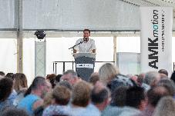
Bild 1: AMKmotion Managing Director Stefan Buchner welcomed around 550 guests to the summer party celebrating the company's 60th anniversary.
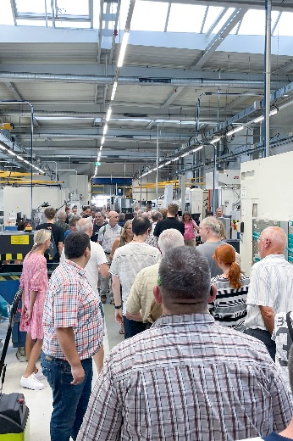
Bild 2: Guided tours through the production gave visitors the opportunity to immerse themselves in the technical world of AMKmotion.
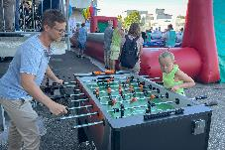
Bild 3: The drive specialists had put together a varied programme for their employees, their families, the AMKmotion pensioners and the guests from the sister company Arburg.
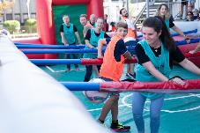
Bild 4: Twelve teams from the AMKmotion workforce competed in the exciting human table soccer tournament. The three winners received great prizes.
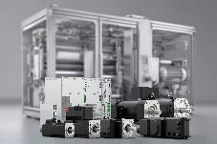
Bild 5: For 60 years, AMKmotion has been supplying its customers all over the world with innovative electrical drive and control technology from Kirchheim unter Teck.
Image credits: AMKmotion GmbH + Co. KG

About AMKmotion
AMKmotion specialises in the development and manufacture of electric drive systems and sees itself as a long-term partner in the field of industrial mechanical engineering and plant engineering. The company’s aim is to help its customers achieve technological leadership by integrating individual and sustainable solutions.
The basis for this is AMKmotion’s hands-on mentality, combined with expertise acquired in more than 60 years of company history. We attach particular importance to personal advice and trusting cooperation with customers.
The company was founded in 1963 as AMK Arnold Müller GmbH & Co. KG. It has belonged to the Arburg family since 2021 and has operated under the name AMKmotion GmbH + Co KG since then. The portfolio includes electric drive technology, control technology and industrial automation technology. AMKmotion has a total workforce of 500 people. In addition to its headquarters in Kirchheim unter Teck, AMKmotion has production sites in Weida (Thuringia) and in Gabrovo, Bulgaria, as well as twelve branch offices around the world.

Contact
AMKmotion GmbH + Co KG
Anja Schaber
Marketing Manager
Gaußstraße 37-39
73230 Kirchheim unter Teck
Germany
www.amk-motion.com
anja.schaber@amk-motion.com
Phone +49 7021 5005 373
Mobile +49 152 5305 5372

