**AMKmotion at the SPS: energy efficiency thanks to hybrid drive solutions**

**the SPS 2023 (14-16 November, Nuremberg) is the meeting place of the automation industry. At the heart of the action: AMKmotion. The developer and manufacturer of electric drive systems will be presenting the full range of its portfolio at Stand 210 in Hall 4. This year’s trade fair appearance focuses on energy efficiency and hybrid drive solutions.**

Efficiency always has to do with a precise fit. Processes can only run safely and efficiently if the solution is tailored to the problem based on needs. This firstly requires a sound knowledge of the parameters, and secondly products that are able to offer a high level of efficiency. This is exactly where AMKmotion comes into play: at the SPS, the drive specialist will be presenting its extensive motor portfolio and central converter technology with the latest generation of controllers, and demonstrating how highly efficient systems can be set up based on intermediate energy storage and energy recovery, for example. The KES compact power feed transfers regenerative energy back to the grid by means of sinus commutation, thereby reducing electricity costs. In addition, the variable DC bus makes the system less dependent on the local power supply voltage.

Another building block towards achieving greater energy efficiency: hybrid drive concepts. Modularized mechanical engineering uses decentralized drives that do their job directly at the point of action. However, power-intensive processes usually require the installation of a central automation solution with a switch cabinet. By combining both solution approaches, users can benefit from the advantages offered by each one. This is particularly easy when the components are at home in both worlds.

**KHY – the hybrid distributor**

One of the ways in which AMKmotion supports its customers is with the hybrid distributor KHY, for example. This simplifies the combination of different signals and supply voltages from the central drive level. In this way, the distributor serves as an intelligent interface to the decentralized drive environment. The standardized interface is designed as a module – simply expanding central switch cabinet devices. Safety fuses are integrated for short-circuit and overload protection. In addition, the KHY monitors the DC bus current and the decentralized drive train via an I²t counter. The switch-off response can be configured individually.

**Decentralized drive technology**

Another component from the hybrid world is the iX decentralized servo inverter. Thanks to its protection class IP65, it is also suitable for mounting close to the motor in harsh environments. It can be supplied both on a decentralized basis and from the central switch cabinet. Several inverters can be wired together based on the daisy chain concept, while the DC bus, STO and 24 volts can be looped to other decentralized controllers via the iX. Real-time communication takes place via a separate fieldbus cable.

AMKmotion will also be presenting its energy-efficient iC servo converter at the SPS. This can supply an axis with up to five kilovolt amps and also provides a DC bus and 24 volts for additional servo inverters. It too has IP65 protection as well as being shock and vibration resistant. Instead of installing the iC in a switch cabinet, the user installs it directly in the machine. This is achieved in a space-saving manner, as the servo converter is accommodated in a light and compact aluminium housing. Further simplifying installation, the AC feed-in only requires one line for the grid connection. An integrated charging resistor also serves as a brake chopper, meaning external components are no longer required.

**Efficient motors**

In addition, AMKmotion will be exhibiting its generation of motors trimmed for energy efficiency with high power density. Here, energy input is only required for the movement itself. Trade fair visitors will get to see the synchronous servo motors of the DT and DD series, for example. The DT motors allow high-torque positioning of larger masses and high cycle rates. The modular and highly dynamic DD motors enable cyclic positioning of low masses.

**AMKmotion at the SPS 2023: Hall 4, Stand 210**

***Meta-Title:*** *Energy efficiency thanks to hybrid drive solutions demonstrated by AMKmotion at the SPS 2023.*

***Meta-Description:*** *AMKmotion will be presenting the full range of its portfolio at the SPS 2023 (14-16 November, Nuremberg) at Stand 210 in Hall 4. This year’s trade fair appearance focuses on energy efficiency and hybrid drive solutions.*

***Keywords:*** *AMKmotion; PLC; energy efficiency; hybrid drive technology; servo inverter; servo converter; synchronous servo motor; compact power feed; hybrid distributor; iX; KHY; iC; KES; DT; DD*

***Social media (for AMK channels):*** *We invite you to visit us at Stand 210 in Hall 4 at the SPS 2023 (14-16 November, Nuremberg). Get to know the full range of our portfolio and find out about energy-efficient and hybrid drive solutions.*

*We look forward to seeing you there!*

*Click here for your free ticket*

***Social media (for editorial departments):*** *AMKmotion will be presenting the full range of its portfolio at the SPS 2023 (14-16 November, Nuremberg) at Stand 210 in Hall 4. This year’s trade fair appearance focuses on energy efficiency and hybrid drive solutions.*

**Captions**

Ein Bild, das Text, Buch, Zahnbürste, Design enthält.

**Image 1:** The hybrid distributor KHY simplifies the combination of different signals and supply voltages from the central drive level.

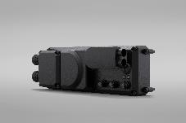

**Image 2:** The energy-efficient iC servo converter can supply an axis with up to five kilovolt amps.

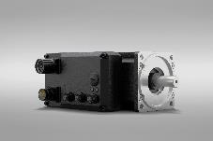

**Image 3:** With the new generation of motors trimmed for efficiency with high power density, energy input is only required for the movement itself.

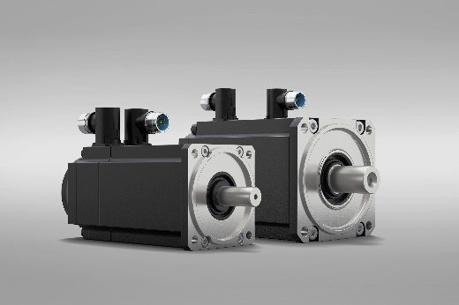

**Image 4:** The modular and highly dynamic synchronous servo motors of the DD series enable cyclic positioning of low masses.

**Image credits:** AMKmotion GmbH + Co. KG

**About AMKmotion**

AMKmotion specialises in the development and manufacture of electric drive systems and sees itself as a long-term partner in the field of industrial mechanical engineering and plant engineering. The company’s aim is to help its customers achieve technological leadership by integrating individual and sustainable solutions.

The basis for this is AMKmotion’s hands-on mentality, combined with expertise acquired in more than 60 years of company history. We attach particular importance to personal advice and trusting cooperation with customers.

The company was founded in 1963 as AMK Arnold Müller GmbH & Co. KG. It has belonged to the Arburg family since 2021 and has operated under the name AMKmotion GmbH + Co KG since then. The portfolio includes electric drive technology, control technology and industrial automation technology. AMKmotion has a total workforce of 500 people. In addition to its headquarters in Kirchheim unter Teck, AMKmotion has production sites in Weida (Thuringia) and in Gabrovo, Bulgaria, as well as twelve branch offices around the world.

**Contact**

AMKmotion GmbH + Co KG

Anja Schaber

Marketing Manager

Gaußstraße 37-39

73230 Kirchheim unter Teck

Germany

[www.amk-motion.com](http://www.amk-motion.com)

[anja.schaber@amk-motion.com](mailto:anja.schaber@amk-motion.com)

Phone +49 7021 5005 373

Mobile +49 152 5305 5372